31st Annual Parish Nurse and Congregational Health Ministries Conference

Dear Sisters and Brothers in Christ,
Welcome to our 31st annual conference! This year’s gathering is based on Colossians 3:12 As God’s chosen people, holy and dearly loved, clothe yourselves with compassion, kindness, humility, gentleness, and patience.
As we prayerfully ask for compassion, kindness, humility, and patience, study His word, and follow His example, we know that our heavenly father has blessed us. We will serve our Heavenly Father in our churches and communities with compassionate service in our congregational health ministries.
This annual national gathering of nurses, pastors, lay ministers, and others is a true blessing. It helps us all focus on our calling to caring vocations, to share and tell the love of Christ, and to serve Him in all we do. It includes blessings to gain new knowledge, network with peers, and share resources to help us all develop new programs and ministries in congregational health.
If you cannot attend this year, I hope to see you at the 32nd annual conference in Mequon, WI on May 15-16, 2024. Our theme will be Caring Alongside: The Essence of Parish Nursing and Congregational Health Ministries. Galatians 6:2 Carry each other’s burdens, and in this way you will fulfill the law of Christ.
Your sister in Christ,
Carol Lueders Bolwerk, PhD, RN
Director of Parish Nursing
Concordia University
262-243-4233
Carol.luedersbolwerk@cuw.edu
Concordia University Wisconsin
CUW is located in Mequon, Wisconsin, 25 miles north of Milwaukee’s Mitchell International Airport.
TRANSPORTATION: Go RiteWay shuttle service is available from Mitchell International Airport to hotels. Call 1-800-236-5450 to make arrangements.
DIRECTIONS – Traveling on Interstate 43:
Construction continues – plan accordingly
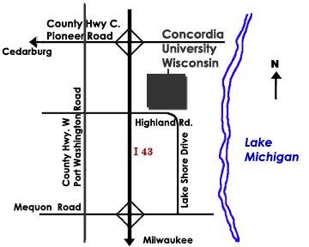
FROM THE SOUTH: Take Mequon Road Exit. Turn Left on Highway W (Port Washington Rd.). Turn right on W to Highland Rd. (2 miles), turn right on Highland, and cross the bridge to CUW on the left.
FROM THE NORTH:
Take the Cedarburg Exit (Pioneer Rd/Highway C). Turn right off the ramp and a quick left onto Highway W (Port Washington Rd.). Go about 2 miles south and turn left onto Highland Rd. Cross the bridge to CUW on the left.
Once you enter the campus driveway, turn right at the Welcome Center stop sign, and follow the roadway to Lot A by the flagpole. Enter the Luther Administration Building and follow the conference signs.

LODGING within five miles (please make your own reservations):
- Baymont Inn & Suites
10330 N. Port Washington Rd., Mequon, WI
262-241-3677
- Hampton Inn & Suites
1385 Gateway Dr., Grafton, WI
262-474-1000
- Comfort Inn & Suites
1415 N. Port Washington Rd., Grafton, WI
262-387-1180
- TownePlace Suites
1601 Gateway Dr., Grafton, WI
262-618-8100

DISABILITY? Concordia is wheelchair accessible!
Compassionate Service

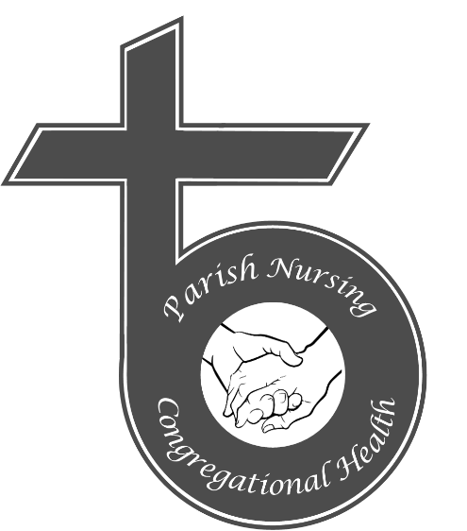

The 31st Annual Parish Nurse and Congregational Health Ministries Conference
May 17-18, 2023

Hosted by:
Concordia University Wisconsin
School of Nursing
12800 North Lake Shore Drive
Mequon, WI 53097
Dr. Carol A. Lueders Bolwerk,
Carol.luedersbolwerk@cuw.edu
262-243-4233
Wednesday, May 17, 2023
All sessions will be in Albrecht Hall
8 AM Registration & Welcome, LPNI Auction

8:30 AM Opening Prayer – Rev. Joe Cottam

8:30 AM The Meros Center: A Research and Training Community for Christian Health Ministry – Jason Paltzer and Bill Meier

9:30 AM Break

10 AM Chapel - Chapel of Christ Triumphant

10:30 AM Building a Solid Foundation for Care through Joy Filled Self-Care – Carmen Stephens

11:30 AM Upheld by God’s Hand: Mental Health Outreach – Tiffany Manor

12:25 PM Prayer – Rev. Joe Cottam

12:30 PM Lunch: sponsored by Concordia Plan Services, St. Louis, MO

1:30 PM 8 Steps to Increasing Quality of Care and Decreasing Workload Stress Using Compassionate, Trained Volunteers – Karen Tripp

2:30 PM Break

2:45 PM Some-Day Jeans: Fitting into God’s Plans – Rev. Dan Paavola

3:30 PM Closing LPNI Auction items distributed

Thursday, May 18, 2023
All sessions will be in Loeber Hall
Breakout sessions will be selected the day of conference.

8 AM Registration - Loeber Hallway

8:15 AM Session A: Fall Prevention in the Community – Carmen Stephens, LO 110

Session B: How Happiness Happens: Finding Lasting Joy – Barb Schroeder, LO 112

Session C: The Days that Were Formed for Me – Tiffany Manor, LO 118

Session D: Nursing the Suffering with Compassion –Rev.James Behringer, LO 101D

9:00 AM Stretch Break

9:15 AM Session E: Help Them Thrive – Rachel Greiner, LO 101D

Session F: When Our Humanity Confines Our Compassion: Lessons from Scripture – Carol DeSchepper, LO 110

Session G: Lessons from the Pandemic Experience: Revisited – Marcia Schnorr and Carol Zimmermann, LO 112

Session H: We Don’t Call Them Shut-Ins Anymore – Christie Hansard, LO 118

10:15 AM Session I: Networking Halfway Around the World: 2022 LPNI Australian Study Tour – Darlene Rueter, LO 101D

Session J: Raising the Positive Energy of Your Home by Eliminating Toxic Elements – Marie Wiegert, LO 110

Session K: 3 Simple, Effective Ways to Serve Long-term Patients and Caregivers – Karen Tripp, LO 112

Session L: Parish Nursing: Managing Stress Before It Manages You – Kathy Zarling, LO 118

11:15 AM Light Lunch Break: sponsored by LPNI

11:45 PM Session M: Getting the Question Right: Survey Tips – Jason Paltzer and Bill Meier, LO 101D

Session N: Be Well, Serve Well: Stress and Self-Care – Kelly Menke, LO 110

Session O: Perceptions of Being Called to Nursing – Carol Lueders Bolwerk, Brenda Jobe, and John Dyson, LO 112

Session P: Caring for the Heart of a Christian Woman – Kathy Zarling, LO 118

12:45 PM Session Q: Diabetes Medication and Treatment Overview – Elizabeth Deck, LO 110

Session R: Journey of Gratitude – Barb Schroeder, LO 112

Session S: How to Use Compassion Everyday – Heidi Then, LO 118

Go now and praise the Lord for all our blessings, rejoicing always, praying continuously, and giving thanks in all circumstances.

Registration Form
Conference Schedule
Name (print clearly or paste address label here):

Address:
City/State/Zip:
Phone:
Email:
Religious affiliation:
☐ Nurse ☐ Clergy ☐ Other
Your name and address will be shared with participants.
PLEASE CHECK DAYS YOU WILL ATTEND:
☐ Wednesday, May 17, 2023 $85.00
☐ Thursday, May 18, 2023 $85.00
☐ Special Clergy Rate – Full Conference $50.00
☐ LPNI Scholarships (first-time attendees): Four $250 scholarships are available for parish nurses from any Lutheran Synod. Email Marcy Schnorr for an application: marcyschnorr2009@gmail.com. Register for conference with full payment. You will be reimbursed after attending conference.
TOTAL FEES ENCLOSED: $
Fee includes all materials and food. Make checks payable to Concordia University Wisconsin (no credit cards, please). Send check and this form to:
Dr. Carol Lueders Bolwerk
Concordia University Wisconsin
12800 North Lakeshore Drive
Mequon, WI 53097
The CDC and CUW COVID-19 precautions will be followed.
CANCELLATION: A refund is available prior to May 1. Refunds will be from less than $50.00 per day.

